Downloading...
From: https://drive.google.com/uc?id=1VJaDVtDUtKQMmhRAqr3t-fgng899ZdRV
To: /content/Python Application Usage Log Data Set.xlsx
100%|██████████| 1.68M/1.68M [00:00<00:00, 140MB/s]
Epoch 1/300
19/19 ━━━━━━━━━━━━━━━━━━━━ 10s 105ms/step - loss: 0.4080 - val_loss: 0.4135 - learning_rate: 0.0010
Epoch 2/300
19/19 ━━━━━━━━━━━━━━━━━━━━ 2s 60ms/step - loss: 0.3248 - val_loss: 0.2865 - learning_rate: 0.0010
Epoch 3/300
19/19 ━━━━━━━━━━━━━━━━━━━━ 2s 100ms/step - loss: 0.3214 - val_loss: 0.3135 - learning_rate: 0.0010
Epoch 4/300
19/19 ━━━━━━━━━━━━━━━━━━━━ 2s 89ms/step - loss: 0.3078 - val_loss: 0.3167 - learning_rate: 0.0010
Epoch 5/300
19/19 ━━━━━━━━━━━━━━━━━━━━ 2s 91ms/step - loss: 0.2893 - val_loss: 0.3305 - learning_rate: 0.0010
Epoch 6/300
19/19 ━━━━━━━━━━━━━━━━━━━━ 1s 44ms/step - loss: 0.2609 - val_loss: 0.3197 - learning_rate: 0.0010
Epoch 7/300
19/19 ━━━━━━━━━━━━━━━━━━━━ 1s 56ms/step - loss: 0.2532 - val_loss: 0.3054 - learning_rate: 0.0010
Epoch 8/300
19/19 ━━━━━━━━━━━━━━━━━━━━ 0s 43ms/step - loss: 0.2454
Epoch 8: ReduceLROnPlateau reducing learning rate to 0.0005000000237487257.
19/19 ━━━━━━━━━━━━━━━━━━━━ 1s 57ms/step - loss: 0.2465 - val_loss: 0.2934 - learning_rate: 0.0010
Epoch 9/300
19/19 ━━━━━━━━━━━━━━━━━━━━ 1s 72ms/step - loss: 0.2587 - val_loss: 0.3023 - learning_rate: 5.0000e-04
Epoch 10/300
19/19 ━━━━━━━━━━━━━━━━━━━━ 2s 46ms/step - loss: 0.2525 - val_loss: 0.3027 - learning_rate: 5.0000e-04
Epoch 11/300
19/19 ━━━━━━━━━━━━━━━━━━━━ 1s 45ms/step - loss: 0.2412 - val_loss: 0.2878 - learning_rate: 5.0000e-04
Epoch 12/300
19/19 ━━━━━━━━━━━━━━━━━━━━ 1s 46ms/step - loss: 0.2262 - val_loss: 0.3102 - learning_rate: 5.0000e-04
Epoch 13/300
19/19 ━━━━━━━━━━━━━━━━━━━━ 1s 50ms/step - loss: 0.2463 - val_loss: 0.3087 - learning_rate: 5.0000e-04
Epoch 14/300
18/19 ━━━━━━━━━━━━━━━━━━━━ 0s 43ms/step - loss: 0.2138
Epoch 14: ReduceLROnPlateau reducing learning rate to 0.0002500000118743628.
19/19 ━━━━━━━━━━━━━━━━━━━━ 1s 52ms/step - loss: 0.2155 - val_loss: 0.3307 - learning_rate: 5.0000e-04
Epoch 15/300
19/19 ━━━━━━━━━━━━━━━━━━━━ 2s 99ms/step - loss: 0.2185 - val_loss: 0.3176 - learning_rate: 2.5000e-04
Epoch 16/300
19/19 ━━━━━━━━━━━━━━━━━━━━ 1s 56ms/step - loss: 0.2168 - val_loss: 0.2995 - learning_rate: 2.5000e-04
Epoch 17/300
19/19 ━━━━━━━━━━━━━━━━━━━━ 1s 50ms/step - loss: 0.2358 - val_loss: 0.3005 - learning_rate: 2.5000e-04

VAL — MAE: 399.26 | RMSE: 582.28 | MAPE: 34.90%
VAL (optimal F1) — thr: 599.3 | Acc: 76.92% | F1: 0.87
Epoch 1/20
20/20 ━━━━━━━━━━━━━━━━━━━━ 4s 20ms/step - loss: 0.4128
Epoch 2/20
20/20 ━━━━━━━━━━━━━━━━━━━━ 1s 21ms/step - loss: 0.3104
Epoch 3/20
20/20 ━━━━━━━━━━━━━━━━━━━━ 0s 21ms/step - loss: 0.3100
Epoch 4/20
20/20 ━━━━━━━━━━━━━━━━━━━━ 0s 19ms/step - loss: 0.2405
Epoch 5/20
20/20 ━━━━━━━━━━━━━━━━━━━━ 1s 19ms/step - loss: 0.2867
Epoch 6/20
20/20 ━━━━━━━━━━━━━━━━━━━━ 0s 19ms/step - loss: 0.2697
Epoch 7/20
20/20 ━━━━━━━━━━━━━━━━━━━━ 0s 20ms/step - loss: 0.2396
Epoch 8/20
20/20 ━━━━━━━━━━━━━━━━━━━━ 1s 25ms/step - loss: 0.2135
Epoch 9/20
20/20 ━━━━━━━━━━━━━━━━━━━━ 1s 32ms/step - loss: 0.2225
Epoch 10/20
20/20 ━━━━━━━━━━━━━━━━━━━━ 1s 31ms/step - loss: 0.2439
Epoch 11/20
20/20 ━━━━━━━━━━━━━━━━━━━━ 1s 21ms/step - loss: 0.2309
Epoch 12/20
20/20 ━━━━━━━━━━━━━━━━━━━━ 1s 19ms/step - loss: 0.2150
Epoch 13/20
20/20 ━━━━━━━━━━━━━━━━━━━━ 0s 19ms/step - loss: 0.2342
Epoch 14/20
20/20 ━━━━━━━━━━━━━━━━━━━━ 0s 19ms/step - loss: 0.2078
Epoch 15/20
20/20 ━━━━━━━━━━━━━━━━━━━━ 0s 20ms/step - loss: 0.2135
Epoch 16/20
20/20 ━━━━━━━━━━━━━━━━━━━━ 1s 19ms/step - loss: 0.2178
Epoch 17/20
20/20 ━━━━━━━━━━━━━━━━━━━━ 0s 19ms/step - loss: 0.2036
Epoch 18/20
20/20 ━━━━━━━━━━━━━━━━━━━━ 1s 19ms/step - loss: 0.1998
Epoch 19/20
20/20 ━━━━━━━━━━━━━━━━━━━━ 0s 19ms/step - loss: 0.1707
Epoch 20/20
20/20 ━━━━━━━━━━━━━━━━━━━━ 0s 21ms/step - loss: 0.1917
/tmp/ipython-input-1333924219.py:194: FutureWarning: last is deprecated and will be removed in a future version. Please create a mask and filter using `.loc` instead
hist_window = data.last('730D') if hasattr(data, 'last') else data.iloc[-104*2:]
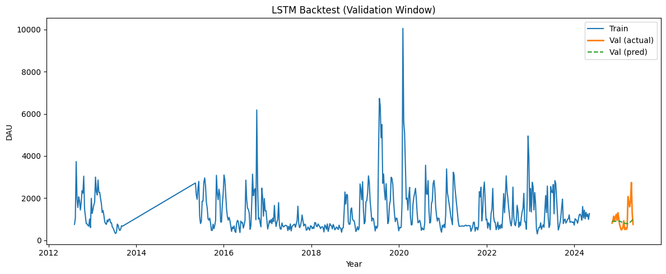
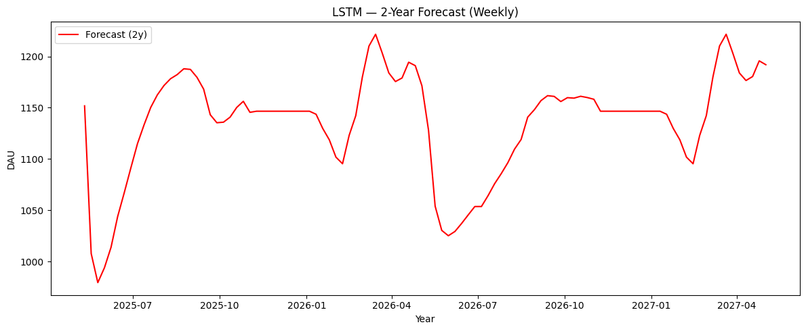

▶ Validation (optimal F1 threshold)
Threshold: 599.313
Accuracy : 76.92%
F1 Score : 0.87
Confusion matrix [TN FP; FN TP]:
[[ 0 6]
[ 0 20]]

▶ Validation (fixed TRAIN-median threshold = 1003.513)
Accuracy : 57.69%
F1 Score : 0.00
Confusion matrix [TN FP; FN TP]:
[[15 0]
[11 0]]

